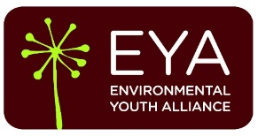

Community Nursery Internship
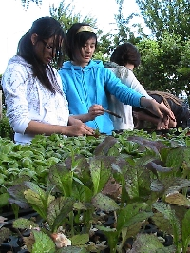
Dig in! The Environmental Youth Alliance is now accepting applications for the spring Community Nursery Internship for youth between 14 and 18 years old.
Learn everything you need to know to grow your own food! Get hands on experience working in an organic vegetable garden and community orchard, helping to maintain two greenhouses, and growing thousands of vegetable plants for under-served communities in East Vancouver. In addition, meet like-minded youth from around Vancouver while earning $150 for your time, and community service hours towards graduation.

Apprentices will be expected to dedicate 5 hours of time per week for 12 weeks beginning the week of March 17th and ending June 2nd. We will spend 2 days a week together: 2 hours on a weekday from 4-6 PM (day yet to be determined), and 3 hours on a weekend day (yet to be determined). Upon completion of the 12 week program, apprentices will receive a certificate and reference from the Environmental Youth Alliance, along with a cheque for $150.
To apply to the Community Nursery Youth Internship, email a resume and brief cover letter explaining why you’d like to be a part of the program to Rebecca Martin at rebecca@eya.ca.
Spring Application Deadline March 4th.
Check out a video about the Community Nursery.
Learn more about EYA here: www.eya.ca
Program Outline:
Week 1 - Growing from Seed: Learn how to propagate commonly grown vegetables from seed. Mix your own potting soil and start seeds in pots in this introductory week.
Week 2 - Soil Ecology: Dig in and discover how to build a healthy soil ecology, including making friends with insects, fungi and bacteria.
Week 3 – Composting: Manage the breakdown of garden and food waste and turn it into gardener's gold.
Week 4 - Organic Growing Principles: Find out why organic matters and practice specific organic methods for getting the most out of your food production sustainably.
Week 5 - Pest and disease control: Learn how to prevent pests and disease first, and earth-friendly tactics for when it does happen.
Week 6 - Field Trip: We’ll take a trip to a professional urban agriculture operation to take a look at how the pros do it.
Week 7 - Selling for market: Engage with community members, tell our story and sell some of the plants you’ve grown at a farmers market.
Week 8 - Perennial propagation from cuttings: Learn and practice this method of perennial plant propagation on native plants and herbs.
Week 9 – Orchards: Maintain the Community Orchard and learn about perennial food production, food forestry and the integrated design system known as permaculture.
Week 10 – Pollination and Bees: Spend some time with a hive of honeybees, very important insects that help produce much of the food we eat.
Week 11 - Winter growing: Learn the keys to growing food throughout the colder months so you can grow a four-season harvest.
Week 12 - Saving seeds: Our last week focuses on the cycle of growth and how to save seeds for next season. Together we’ll celebrate your completion of the program!
Apply today by emailing your resume and cover letter to rebecca@eya.ca.
Have questions? Contact Rebecca via email or phone at (604) 689-4446.

